**IMPORT EXCEL**

**INSTALL Yii2 EXPORT**

composer require --prefer-dist hscstudio/yii2-export "1.0.0"

**INSTALL EXTENSION**

composer require phpoffice/phpspreadsheet

FOR DOCUMENTION

<https://phpspreadsheet.readthedocs.io/en/latest/>

**BUAT EXCEL FILE (sesuaikan kebutuhan)**

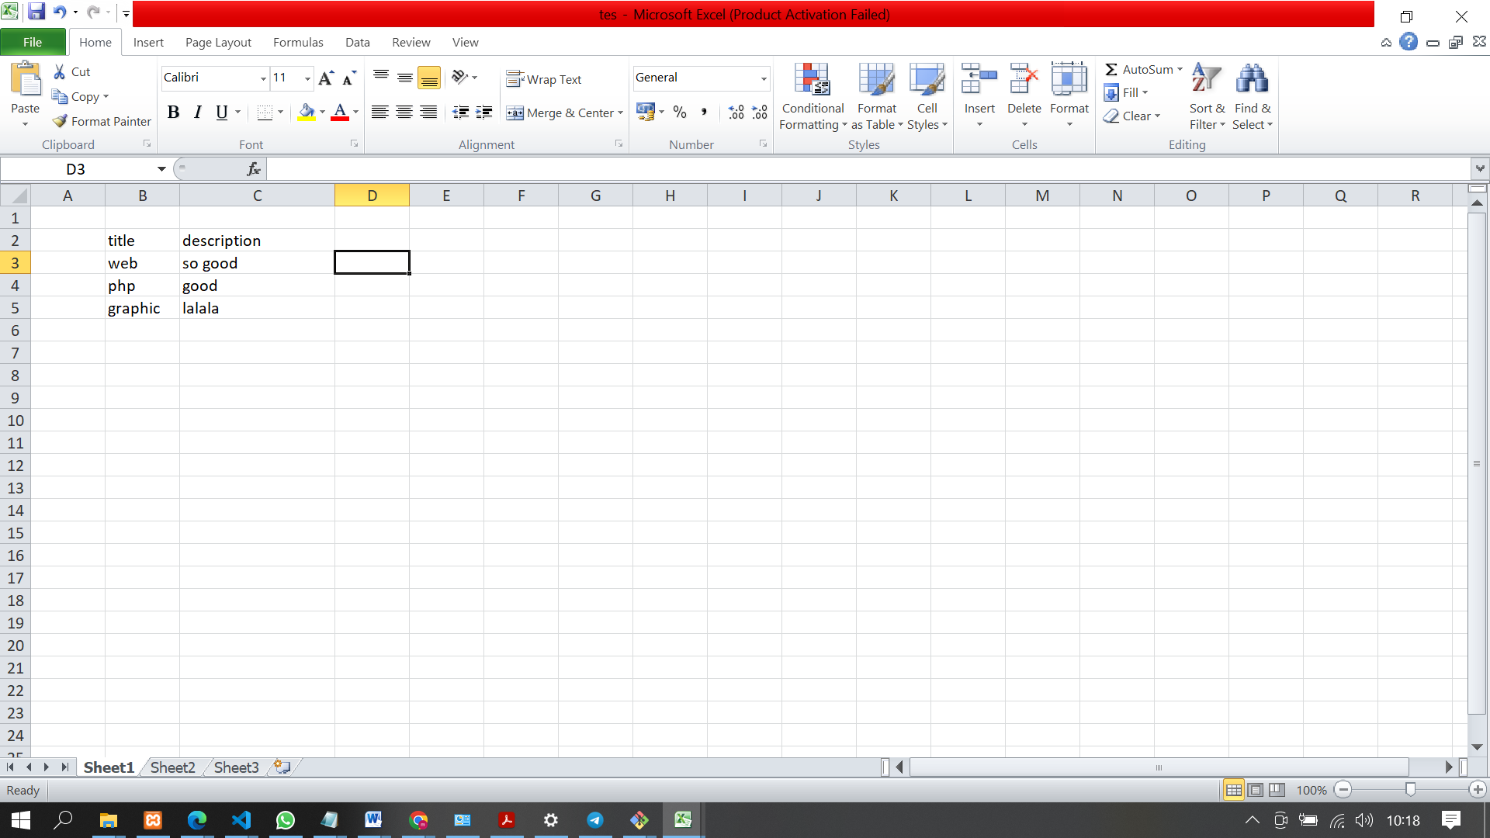

**SALIN DI CONTROLLER (sesuai table)**

**Tambahkan terlebih dahulu use Yii dan**

use PhpOffice\PhpSpreadsheet\IOFactory;

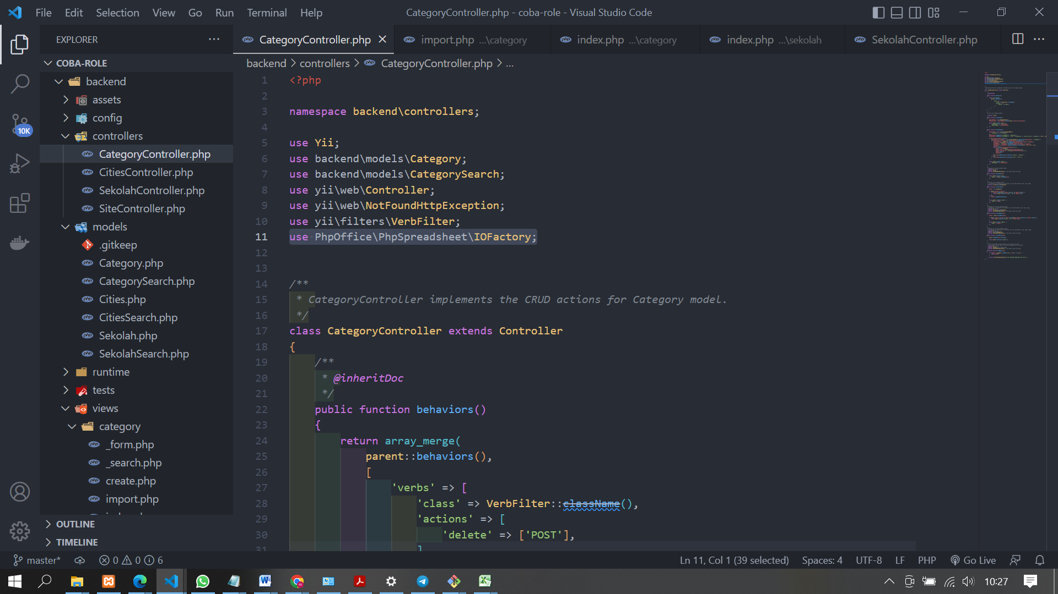

public function actionImport(){

$modelImport = new \yii\base\DynamicModel([

'fileImport'=>'File Import',

]);

$modelImport->addRule(['fileImport'],'required');

$modelImport->addRule(['fileImport'],'file',['extensions'=>'ods,xls,xlsx'],['maxSize'=>1024*1024]);

if(Yii::$app->request->post()){

$modelImport->fileImport = \yii\web\UploadedFile::getInstance($modelImport,'fileImport');

if($modelImport->fileImport && $modelImport->validate()){

$inputFileType = IOFactory::identify($modelImport->fileImport->tempName);

$objReader = IOFactory::createReader($inputFileType);

$objPHPExcel = $objReader->load($modelImport->fileImport->tempName);

$sheetData = $objPHPExcel->getActiveSheet()->toArray(null,true,true,true);

$baseRow = 3;

while(!empty($sheetData[$baseRow]['B'])){

$model = Category;

$model->title = (string)$sheetData[$baseRow]['B'];

$model->description = (string)$sheetData[$baseRow]['C'];

$model->save();

$baseRow++;

}

Yii::$app->getSession()->setFlash('success','Success');

}else{

Yii::$app->getSession()->setFlash('error','Error');

}

}

return $this->render('import',[

'modelImport' => $modelImport,

]);

}

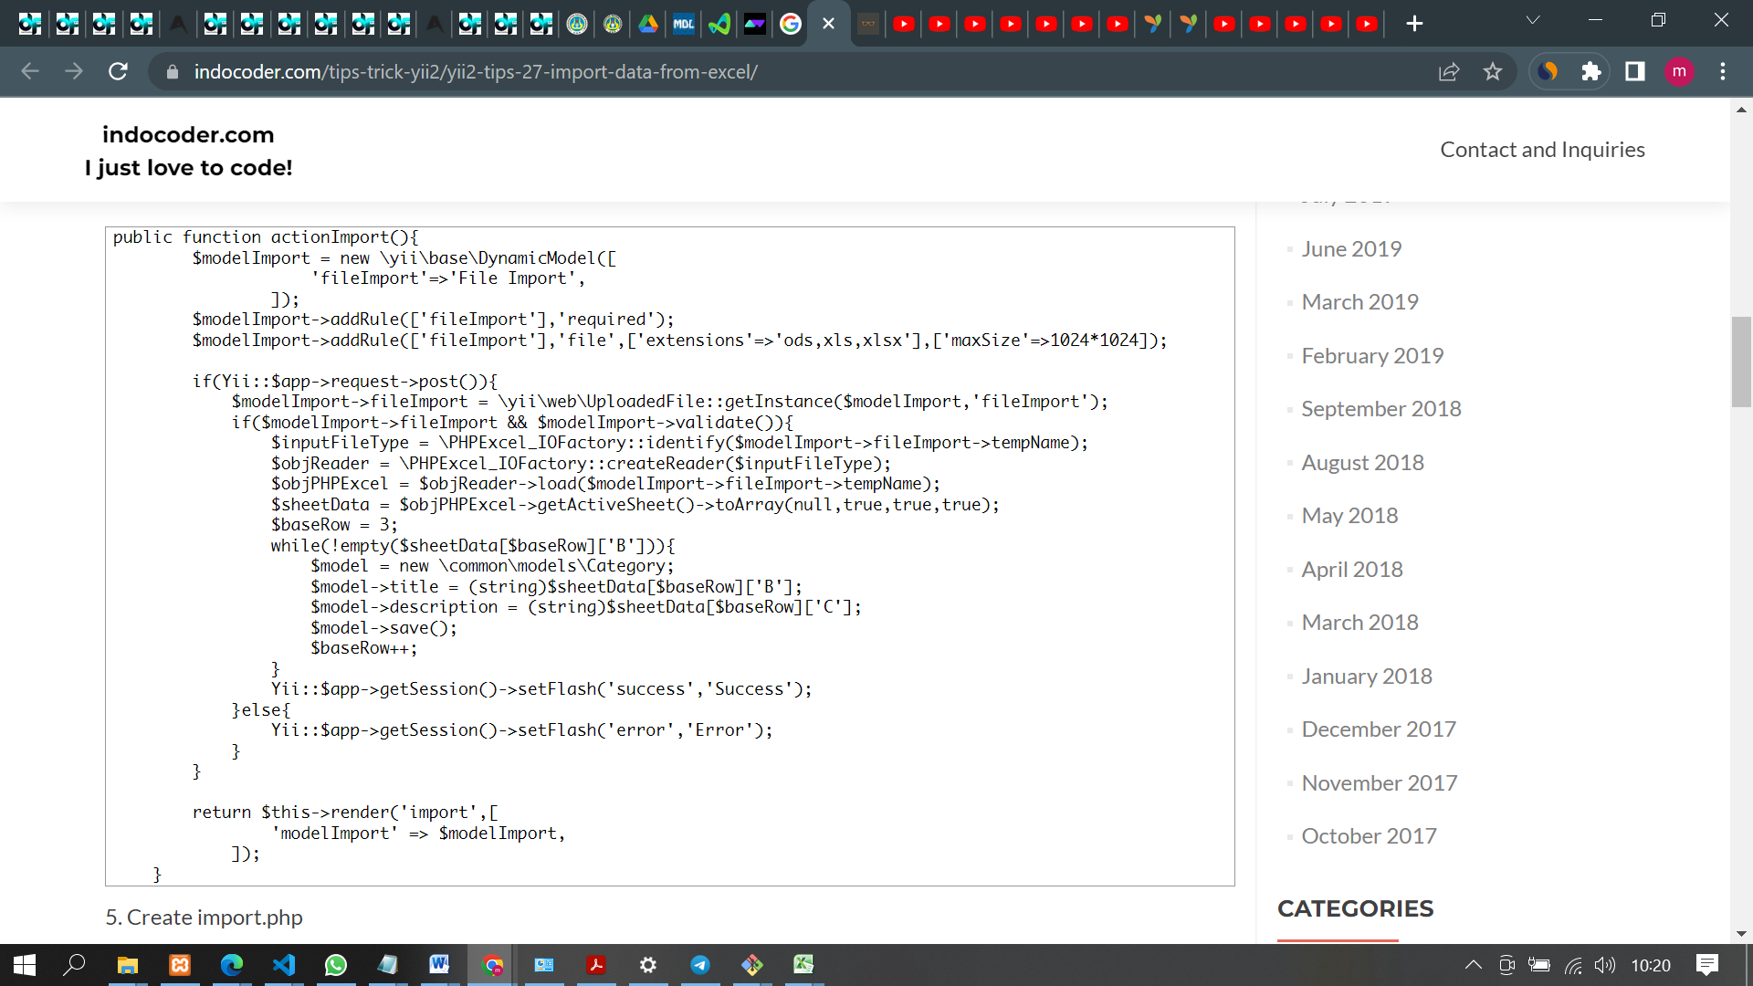

**BUAT FILE import.php DI FOLDER**

<?php

use yii\widgets\ActiveForm;

use yii\helpers\Html;

?>

<h1>Import Data</h1>

<?php $form = ActiveForm::begin(['options'=>['enctype'=>'multipart/form-data']]);?>

<?= $form->field($modelImport,'fileImport')->fileInput() ?>

<?= Html::submitButton('Import',['class'=>'btn btn-primary']);?>

<?php ActiveForm::end();?>

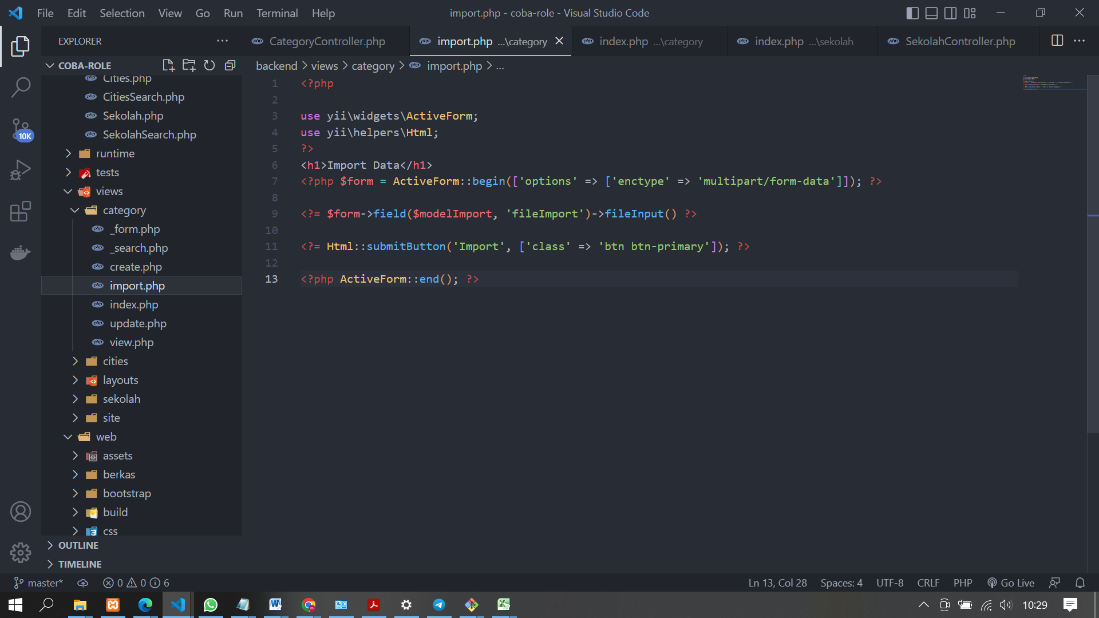

**BUAT BUTTON DI INDEX.PHP**

